9 April 2020
Cooperative Workplaces Consultation
Attorney-General's Department
Canberra ACT
IRconsultation@ag.gov.au

Thank you for conducting this consultation on how Australia can capture productivity improvements from more harmonious workplace relations, and for inviting submissions.
On behalf of the Australian HR Institute (AHRI), I am pleased to make this submission.
AHRI is the peak body for Australian HR practitioners and people managers. AHRI represents around 20,000 HR practitioners across Australia
In order to gather relevant data to make this submission, in February 2020 we surveyed a national sample group of 407 AHRI members using as a base the questions contained in the Attorney General’s discussion paper.
Figures 1–5 and Tables 1-2 below set out some details of that sample group under standard demographic headings. AHRI’s recommendations are provided below, followed by summary commentary and data drawn from the survey results.

Recommendations
Based on the input from the AHRI survey, I would like to make the following recommendations:
- That, in keeping with the recommendations of the 2018 Hayne Royal Commission, the business indicator relating to corporate cultures based on trust and shared values, be supported by the policies and actions of government, its relevant agencies and regulatory bodies

In keeping with the same recommendations, that distortions in short-term incentives be corrected by encouraging intangible indicators such as business leadership that aligns its walk with its talk, and that communicates its values clearly and consistently to its people, its customers, and the general public

- That government notes that since 2015, the Australian HR peak body, AHRI, has introduced certification for the HR profession to ensure that HR practitioners have the capability to talk the language of business, and with respect to people management, are demonstrably able to do what they say they can do

- That along with the other key functions of business, the HR function is recognised and empowered to be accountable for the acceptance and enacting of a corporate culture supported by the CEO that delivers on promises to customers, engages people who are committed to that culture, trains people to live up to the culture, and builds sustainable value for the organisation

- That a professional and credible HR function has the capability to communicate on business priorities with all stakeholders in the business, including the CEO, executives and union leaders

- That a revised industrial relations system should:
  - be simplified (including the framework, language, tools and resources)
  - encourage a more cooperative, consultative approach in working with unions
  - enable enterprise bargaining to be more constructive
  - provide funding for employers and unions to enable better collaboration
  - incentivise employers who are innovative and who report few claims and disputes
  - provide employers with more flexibility within the framework
  - provide employers with more tools, education, resources and training on the framework itself.

Survey of HR practitioners
Cooperation and productivity
As indicated in Figures 6 and 7, around seven out of ten respondents (67.6 per cent) report their belief that employees benefit to a large extent from cooperative workplaces, while six out of ten (61.9 per cent) believe that that there are productivity benefits to be gained from cooperative workplaces.
The disparity in relation to respondent observations about the respective merits of employee benefits and productivity benefits of cooperative workplaces are worthy of brief comment. The disparity suggests that while there is a strong majority view that cooperative workplaces contribute to employee wellbeing, workplace engagement, capacity to attract talent, and innovation, those benefits do not translate to the same extent into improvements in productivity. Put another way, it might be said that a happy employee may not be fully productive, but it can be said with a high degree of confidence that a disengaged employee will not be productive.
The challenge for workplaces in general, and HR practitioners in particular, is to find ways to close that gap. The survey identified in Table 3 that cooperative workplaces contributed towards the benefits of employee health and wellbeing, workplace engagement, talent attraction and innovation. While these attributes are vital and well worth cultivating and retaining, competent employees need also to be productive.
A straight line cannot necessarily be drawn between innovation and productivity, for example, but the connection between an enterprise being productive and being competitive are compelling, and genuine innovation is also one of the accepted contributors to competitiveness. Accordingly, one of the capabilities of sound management and good HR practice is to determine those areas of the business to which appropriate productivity measures can sensibly be applied while at the same time ensuring that workplace conditions are such that employees are motivated to bring their best selves to work and to contribute to the mission of the enterprise.
On the two general matters of the benefits of cooperative workplaces and the benefits to productivity, the disparity in respondent data is small, and when the ‘to a moderate extent’ responses are added to the ‘to a large extent’ responses the survey positivity is 94 per cent and 92 per cent respectively, the difference suggesting a difference in degree of enthusiasm rather than a difference in kind.
Successful and unsuccessful initiatives used to enable cooperative workplaces
The most successful initiatives to enable cooperative workplaces were ranked by respondents, as shown in Figure 8. The top five initiatives identified as very successful were:
- Cultures based on mutual trust and shared values
- Comprehensive, clear and consistent communication systems
- Employee engagement
- Leadership development
- Alignment between individual jobs and organisational aims.
The three least successful initiatives, as shown in Figure 8, were:
- Performance based pay
- Flat accountability structures
- Retraining for new jobs created by new technology.
The three identified by respondents as the least successful are visible, and give users relatively immediate feedback, and so they enjoy a degree of popularity. But they tend to be knee-jerk blunt instruments and are seen as such by the majority of respondents to this survey.
For the same reason, the five most effective initiatives tend to be employed less frequently by organisations, probably because they are more difficult to measure and do not provide the immediate gratification of yielding short-term results. Regarded in some circles as ‘soft’, these five attributes - (1) developments in culture based on trust and respect, (2) clear communication, (3) employee engagement, (4) leadership development, and (5) alignment of individual and organisation objectives – are seen as vital by most respondents.
They are also seen as both critical and neglected attributes by the 2018 Hayne Royal Commission into misconduct in the finance sector. The Commission saw them as neglected key performance indicators in many organisations which it put down to their not being indicators with a direct financial connection. The Commission showed beyond doubt, however, that they are indicators of organisational value that connect to long-term sustainability. It also showed that they have the potential, if not regarded with sufficient seriousness, to negatively affect reputation, customer loyalty, revenue generation and profitability. The Commission formally recommended that regulators insist that organisations allocate greater importance to indicators such as these five, in the interests of their customers, their shareholders and the general public.
Enablers and barriers to achieving cooperative workplaces
Enablers
Regarding the top five successful initiatives for achieving cooperative workplaces as identified by the survey respondents, respondents were asked in addition to indicate enablers in achieving them as well as barriers preventing their uptake.
Table 4 lists a summary of the most commonly identified enablers which include transparency, executive support, accountability, good feedback channels, consultation, trust, talent identification, clear organisation goals, and honest management.
AHRI’s internationally benchmarked Model of Excellence lists ten corporate attributes that HR practitioners seeking professional certification are required to demonstrate. These behavioural attributes are being credible, professional, future oriented, solutions driven, a critical and enquiring thinker, courageous, collaborative, a resolver of issues, an influencer, and with the capacity to understand and care. The attributes underpin AHRI’s professional certification credential and make demands on character. Like the enablers listed by the survey respondents, they build organisational capability in a more sustainable way than blunt instruments such as performance-based pay and narrow job training.
Barriers
Similarly, the barriers to achieving cooperative workplaces that are listed in Table 5 by respondents relate very much to things that prevent the achievement of these ‘soft’ attributes which are actually hard, and include issues such as not walking the talk, behaviours not aligning to values, inconsistent messages, lack of follow-up, burdensome hierarchy, leader indifference, inappropriate training, no long-term approach, wrong people appointed to leadership roles, no strategic plan, failing to engage low level staff in strategy, and lack of succession planning.
Other enabling initiatives
In addition to initiatives enabling cooperative workplaces supplied to respondents from the Cooperative Workplaces Discussion Paper, AHRI invited survey respondents to suggest other initiatives not on that list.
Table 6 shows that from 125 responses, three initiatives often mentioned were employee flexibility, team related matters, and consultation. The verbatim quotes listed in Table 6 are a sample of the views that pick up on matters such as flexible work practices and hours, team meetings and team building, and the merits of 1:1 follow up meetings, as well as internal and community consultation.

The industrial relations system and cooperative workplaces
A little more than half of respondents either disagree or strongly disagree (50.5%) that the Australian industrial relations system supports and encourages cooperative workplaces, as shown in Figure 9. Around one in five (21.3%) either agree or strongly agree that the IR system encourages cooperative workplaces, with more than a quarter (28.2%) neutral on the question.
What could the IR system do better?
Table 7 shows a selection of responses from 183 respondents. Under the heading of education, respondents suggested educating employees who would like to become negotiators, and also educate others on questions of business profitability pinch points. They called in addition for educating union members and employers on matters such as the Fair Work Act and best practice.
Some respondents called for limiting the power of unions on matters such as enterprise bargaining and right of entry, as well as encouraging union representatives to be more supportive and less adversarial.
On bargaining, there were calls for exercising more good faith and understanding in enterprise bargaining, bargaining directly with employees rather than unions, and either finding a replacement for bargaining or just getting rid of it if union delegates do not show an understanding of commercial realities.
On flexibility, respondents called for a freeing up of the IR framework so that employers could get more flexible bargaining at the enterprise level, noting that each business is different. The better-off-overall-test (BOOT) was seen as a barrier to bargaining flexibility for employers.
Calls were made by respondents for simplification of awards to prevent disputes arising from confusion and complexity, and for the process to allow issues to be dealt with more easily. Expressing instruments in plain English without reducing conditions was another call.
How could unions contribute?
Table 8 sets out three ways in which unions could contribute: consultation and collaboration, a less combative approach, and funding, from 182 responses.
There were repeated calls for a less adversarial approach, and some respondents saw a lack of framework for collaboration.
There were also observations made about union militancy, ignorance and use of scare tactics, and giving employers who are trying to do the right thing a better go.
Some respondents thought more funding for cultural change programs would help, as well as for regulators to be more effective.
What can the Government do?
Table 9 looks at government recommendations coming from 176 respondents, such as tools and resources that government could provide. Specifically, respondents suggested showcasing quality employers rather than faulty ones, and better tools and resources focusing on purpose, values and vision on fair work for starting businesses.
Respondents called for simplification of the award structure, the industrial framework, the Fair Work website and administrative burdens on employers.
Some respondents thought government could incentivise innovative companies and public sector bodies that support social and equity initiatives. Government could also incentivise employers that had none or very few claims or disputes. Others thought leadership grants to not-for-profits could be useful, as well as HR support for small to medium enterprises.
I would be pleased to be kept informed of the outcomes of this consultation.
Sincerely,
Sarah McCann-Bartlett
Chief Executive Officer

APPENDIX

FIGURES AND TABLES
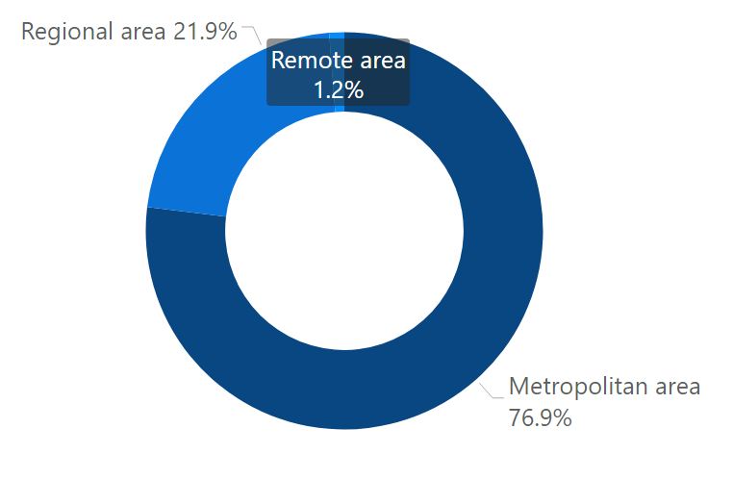
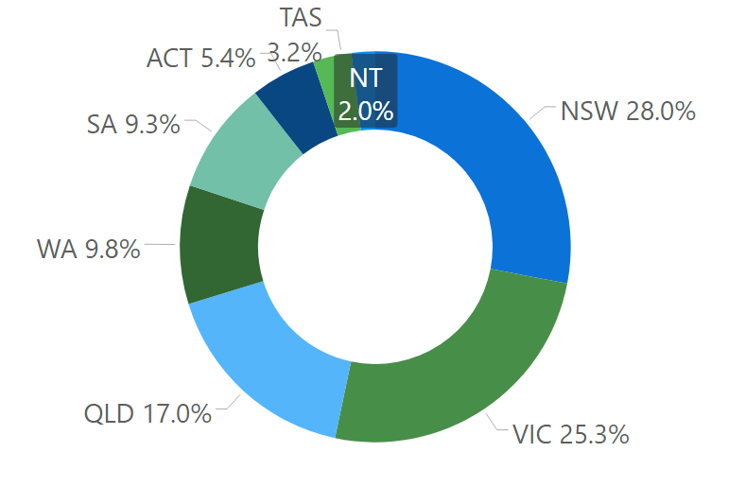

Figure 1. Location (n=407)

Figure 2. State (n=407)

The majority of survey respondents were from a metropolitan area (76.9%) as demonstrated in Figure 1, and resided in New South Wales (28%), Victoria (25.3%) and Queensland (17%), as shown in Figure 2.
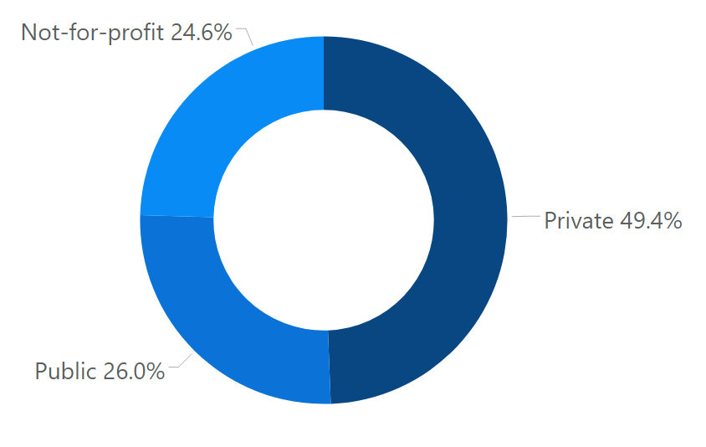

Figure 3. SECTOR (n=407)

The majority of respondent organisations were in the private sector (49.4%), as shown in Figure 3. Further, the majority were from small organisations (1-99 workers; 31.2%), medium size organisations (100-499 workers; 30.2%), or very large organisations (1000+ workers; 29.7%), as shown in Figure 4.

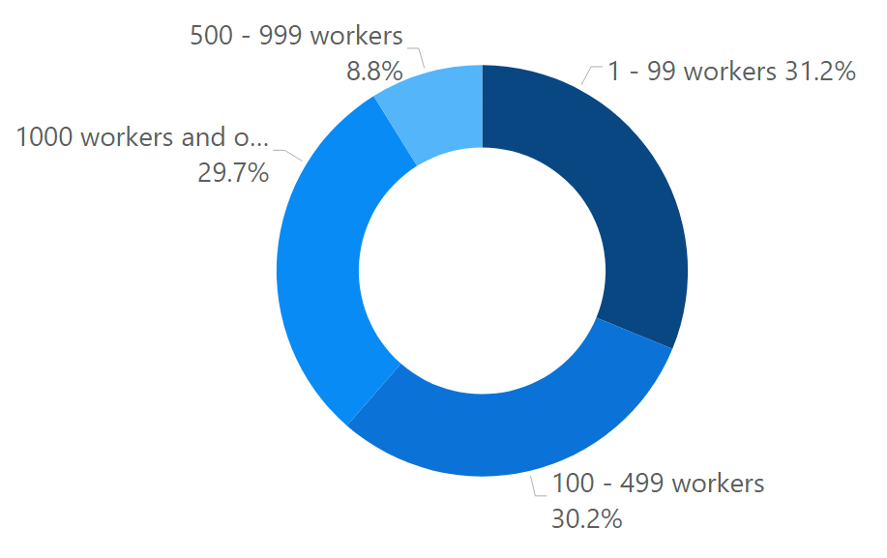

Figure 4. Organisation size (n=407)

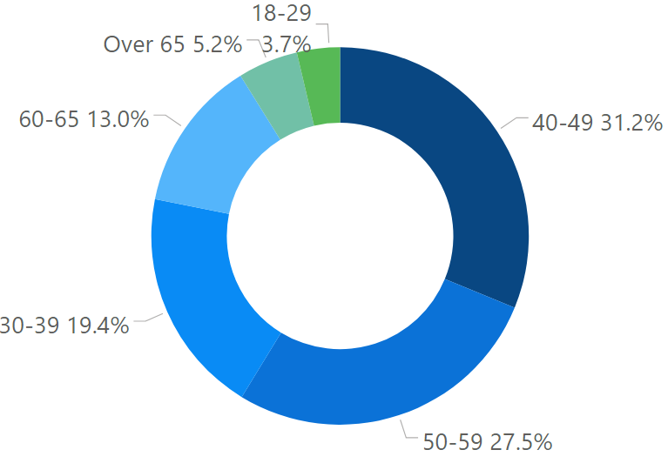
The largest proportion of age groups was between 40-49 years (31.2%), followed by 50-59 years (27.5%), as shown in Figure 5.
The top 3 industries that respondents reported as working in were Healthcare and Social Assistance (18.2%), Education and Training (14%), and Professional, Scientific and Technical Services (11.6%), as demonstrated in Figure 6.
Further, a large majority of respondents reported themselves as being in a HR Manager role (29%), as shown in Figure 7.

Figure 5. age (n=407)

table 1. industry (n=407)
Industry | %
Healthcare and Social Assistance | 18.2%
Education and Training | 14.0%
Professional, Scientific and Technical Services | 11.6%
Public Administration and Safety | 6.4%
Manufacturing | 6.1%
Transport, Postal and Warehousing | 3.7%
Electricity, Gas, Water and Waste Services | 3.2%
Financial and Insurance Services | 3.2%
Administration and Support Services | 3.0%
Accommodation and Food Services | 2.5%
Mining | 2.5%
Construction | 2.2%
Agriculture, Forestry and Fishing | 2.0%
Retail Trade | 1.7%
Arts and Recreation Services | 1.2%
Information Media and Telecommunications | 1.0%
Wholesale Trade | 1.0%
Rental, Hiring and Real Estate Services | 0.5%
Other services | 16.2%

table 2. jOB ROLE (n=407)

Job role | %
HR Manager | 29.0%
HR Business Partner | 9.6%
HR Consultant | 8.9%
HR Adviser | 8.6%
HR Director (national focus) | 7.9%
HR Director (state focus) | 5.7%
Consultant | 5.2%
Senior Executive team | 5.2%
HR Director (global focus) | 3.2%
Academic | 2.2%
Contract/freelance | 2.2%
HR Administrator | 2.2%
CEO | 1.5%
Line Manager | 1.5%
Board Director | 0.5%
Other | 6.9%

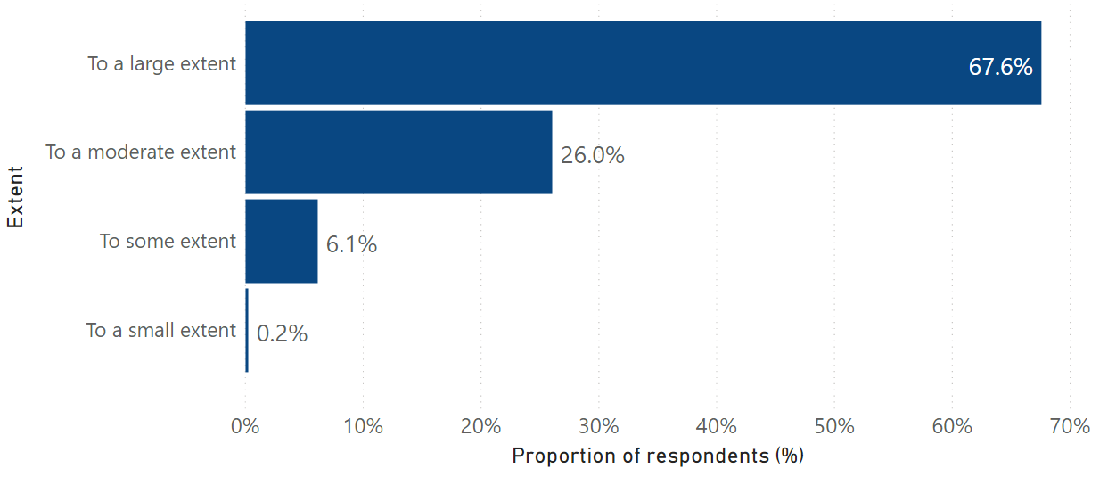

Figure 6. To what extent do employees benefit from cooperative workplaces? (n=407)

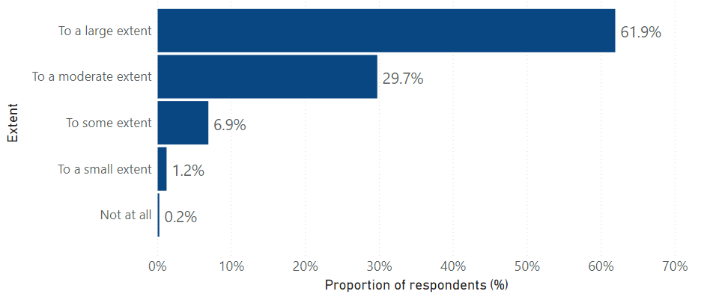

Figure 7. To what extent do productivity benefits arise from cooperative workplaces? (n=407)

table 3. ADDITIONAL BENEFITS OF COOPERATIVE WORKPLACES – Sample comments from respondents (n=359)
Themes | Examples
Health & wellbeing (84 respondents) | “Healthy and motivated workers are more committed and productive”  “Reduced mental health difficulties has an economic and social benefit for our society”  “Improved mental health and wellbeing (reduced costs for ill health particularly mental health”  “Greater employee physical and mental health”  “Less mental health issues (related to stress) in staff”
Employee engagement (41 respondents) | “Better engagement in achievement of business outcomes and services to community”  “Better engagement with our clients”  “Greater engagement and participation in team discussions and planning”  “Employee engagement”  “Engagement of workforce promotes productivity and consistency this can generate a level of efficiency across industry and nationally”
Attraction & retention (38 respondents) | “Businesses that meet the definition of 'cooperative' are more likely to attract and retain high quality staff”  “Easy to retain and attract talent”  “Retention rates are higher, replacement costs are lower”  “Better employee retention and contribution”
Innovation (21 respondents) | “Allows for opportunities for innovation”  “Innovation, Creativity through greater engagement”  “Higher levels of cooperation and collaboration and a focus on building a constructive engaged culture has a positive correlation with workplace agility, flexibility and innovation”  “Product, service and infrastructure innovation”  “Relationships, knowledge sharing and innovation”
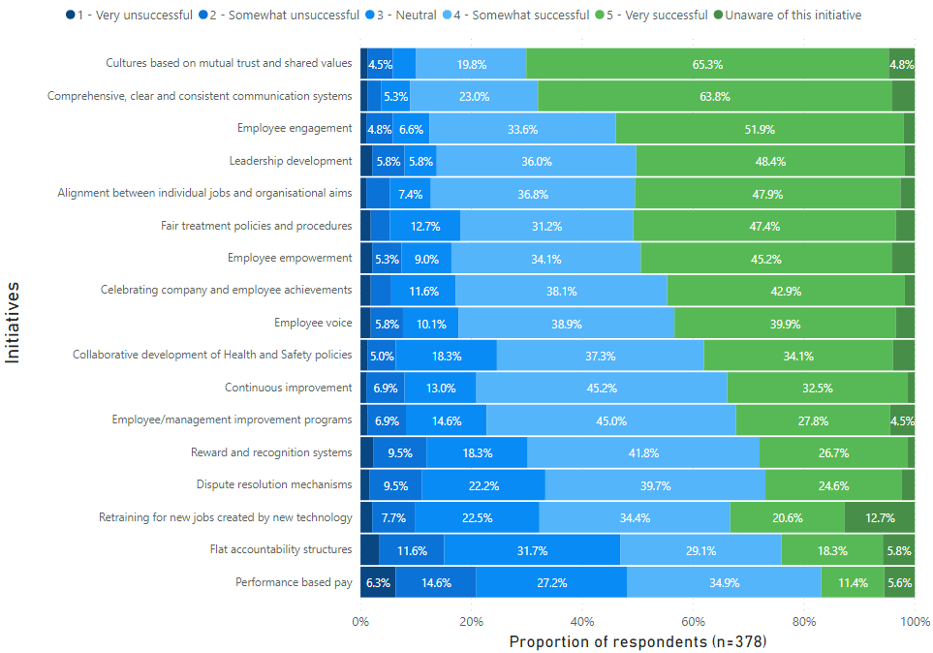

Figure 8. ranked success of the following initiatives to foster cooperative workplaces (n=378)
N.B.: Initiatives are ranked by respondents from most to least successful.

table 4. Enablers TO the top 5 most successful initiatives – themes from respondent comments (n=142)
Most successful initiatives | Enablers
1 - Cultures based on mutual trust and shared values | Transparency, autonomy, CEO support and leadership, executive support, a long-term focus, leaders role modelling, visibility, values linked to behavioural expectation, accountability, honest management, clear policies and fair and consistent administration of them, cultural assessment processes
2 - Comprehensive, clear and consistent communication systems | Transparency, digitisation, ability of management to understand the benefits, good feedback channels, clear accountability for messages, HR involvement, utilising a range of communication systems, regular weekly communications, meeting minutes
3 - Employee engagement | Regular surveys, employee engagement programs, communication and empowerment, consultation, executive support, flexible working arrangements, trust, market competition, excellent position descriptions
4 - Leadership development | Alignment with company direction and career aspirations, allocated PD budget, CEO and leadership team buy in, opportunities for self-reflection, quality training providers, talent identification and retention, holistic programs
5 - Alignment between individual jobs and organisational aims | Clear and simple job descriptions, communication, clear organisational goals, measurable alignment, job analysis, management support, PD which is value aligned, strong inductions, talent management, team engagement

table 5. BARRIERS TO the top 5 most successful initiatives – themes from respondent comments (n=126)
Most successful initiatives | Barriers
1 - Cultures based on mutual trust and shared values | Intergenerational and intercultural miscommunication, failure of board and CEO to model organisational culture, lack of transparency, management resistance, not ‘walking the talk’, leader behaviours not aligning with values, values not identified/shared/lived
2 - Comprehensive, clear and consistent communication systems | Lack of communication, cultural differences, cost of technology, remote workforces, inconsistent messages, information overload, management capability, not defining the problem before implementing procedures, senior management not talking to employees, the culture top to bottom, larger bureaucratic organisations, lack of face-to-face communication
3 - Employee engagement | Burdensome hierarchy, culture lacking change acceptance, employees choosing not to engage, honesty and trust barrier, fear of  HR compliance, lack of follow up on engagement initiatives, poor leadership, mobile workforce, management accountability and lack of follow-up
4 - Leadership development | Cost, time and disruption to operations, leader availability, indifference, inappropriateness of training on offer leading to low uptake, been seen as a ‘tick and flick’ exercise, no long term approach, wrong people being appointed to leadership roles
5 - Alignment between individual jobs and organisational aims | Lack of employee involvement and poor capability of managers in job design, lack of communication, no strategic plan, organisational aims not being articulated, lack of succession planning, ineffective job analysis processes, low level staff not interested in strategy

table 6. examples of other successful initatives - Sample comments from respondents (n=125)
Themes | Examples
Employee flexibility (17 respondents) | “Employer support for workplace flexibility”  “Flexible work practices”  “Utilisation of flexible work wherever possible”  “we recognise that people's needs change, and hence the organisation needs to be as flexible as the employee”  “Managing the amount of flexibility”
Team meetings and team building (15 respondents) | “Daily team meetings for information exchange”  “Team WIP meeting early Monday”  “Team lunches irregularly (usually quarterly)”  “Virtual daily check-ins with team members”  “Team building and bonding”
Consultation (12 respondents) | “1:1 weekly meetings - with a script and check in list for managers/supervisors to follow if necessary, but also to record individual info for action, follow up etc, covering wide variety of areas not just work tasks”  “Consultative committees on critical issues”  “Community consultation”  “Regular consultation with a purpose”  “Consultative committees that consults on all aspects of the business, not just safety or quality”
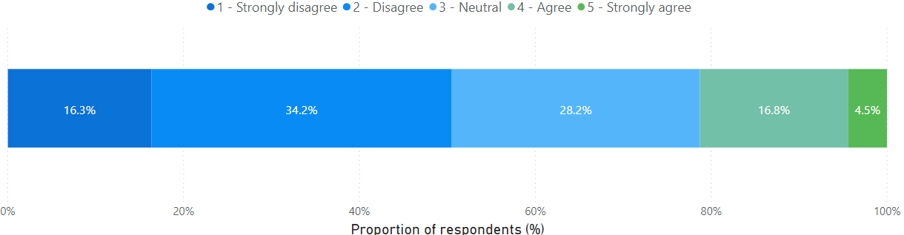

Figure 9. Do you agree that the Australian industrial relations system supports and encourages cooperative workplaces? (n=202)

table 7. What the australian industrial relations system could do better in supporting and encouraging cooperative workplaces - Sample comments from respondents (n=182)
Themes | Examples
Education, training, resources and workshops (55 respondents) | “Education for those employees who are looking to become skilled in negotiation”  “Education of union members”  “Offer more access to training and education’  “Create education programs so that workers understand profitability pinch points and the impact on the economy if Australia does not maximise the utilisation of the available workforce”  “Focus time, energy and funds on providing more education to employers (free workshops, seminars, webinars – fair work, current best practice etc), in particular for those who lack the funding for training & educating”
Reducing union power/aggressiveness (30 respondents) | “Limit the power of unions”  “It appears the balance of power is with the unions and workers. Industrial action can financially cripple a business.”  “Less power for unions regarding enterprise bargaining and right of entry  “Bargaining done with employees not unions”  “Encourage unions/representatives to be supportive not adversarial”
Bargaining (26 respondents) | “Bargaining done with employees not unions”  “Develop a replacement for enterprise bargaining”  “Allow real bargaining to occur or get rid of bargaining”  “They could learn the meaning of bargaining in good faith; they could learn and accept that not every employee grievance is genuine or reasonable”  “Be more supportive of bargaining processes – understand commercial realities of operating a business in the current industrial landscape”
Employer flexibility (19 respondents) | “Greater flexibility within the IR frameworks”  “Free up the IR framework to allow greater more flexible bargaining to be achieved at the enterprise level”  “Becoming more flexible in their approach”  “Recognise that each business is different and employees require flexibility these days to mould things in ways that suit them”  “Greater flexibility in enterprise level arrangements – the BOOT is a significant barrier”
Simplification (12 respondents) | “Reduction of complexity, further simplification of modern awards”  “Simplify awards to prevent misunderstanding for all stakeholders and prevent disputes arising from confusion and complexity, as that leads to stifling cooperation in workplaces”  “Simplify the process to allow issues to be dealt with more easily”  “Industrial instruments need to be simplified into plain English without reducing conditions”  “Simplified EA process”

table 8. How unions can contribute to more cooperative workplaces - Sample comments from respondents (n=184)
Themes | Examples
Less combative approach (46 respondents) | “If they were not so militant and ignorant, they might attract more members and have more effective consultation with management”  “Telling the truth rather than using their scare tactics”  “Change their orientation from adversarial to partnering”  “Stop being so adversarial and partner with industry”  “Stop being so abrasive to employers who are doing the right thing, it is very clear that they treat all employers the same whether they are good, bad or ugly”
Consultation & collaboration (27 respondents) | “Set a framework for collaboration”  “Focus on collaboration and business improvement”  “They can adopt a more collaborative approach rather than an adversarial one”  “Unions must be less militant and self-focussed, and more collaborative”  “Cut down the level of adversity and focus more on the importance of collaboration – this requires effort on all sides”
Funding (15 respondents) | “Provide funding and support for cultural change programs”  “Funding of initiatives to increased engagement linked to evaluation”  “Give regulators more funding and head count to be more effective”  “Continue to fund and strengthen all public sector bodies associated with this support”  “Funding and resources (such as liaison officers) for employers to engage vulnerable employees”

table 9. WHAT DO YOU BELIEVE THE GOVERNMENT COULD DO TO ASSIST EMPLOYERS IN ENGAGING WITH EMPLOYEES? – SAMPLE COMMENTS FROM RESPONDENTS (n=176)
Themes | Examples
Tools and resources (24 respondents) | “Better tools and resources on items such as purpose vision and values on fair work for starting businesses – even outside of Fair Work’s page”  “Education, advisory service and support”  “Greater availability and understanding of the New Approaches model”  “Showcase the good work of quality employers rather than always highlighting the mistakes”  “Improve access to formal and job-related skills and knowledge development”
Simplification (15 respondents) | “Improve the industrial framework to make it easier for employers to comply with and simpler for employees to understand”  “Simplify the award structure”  “Simplify the Fair Work website to make it more easily accessible for all”  “Simplifying industrial instruments into plain English to improve compliance”  “Simplify administrative burdens put onto employers”
Government incentives (14 respondents) | “Incentivise companies that are innovative or that support social / equity initiatives”  “Continue to fund and strengthen all public sector bodies associated with this support”  “An incentive for employers for having no or very little claims or disputes where normally they have many”  “Provide small to medium businesses rebated HR support”  “Grants to non-profits for leadership development”

